**Healthcare Health Camps Analysis**

### **About MedCamp**

MedCamp organizes health camps in several cities with low work-life balance. They reach out to working people and ask them to register for these health camps. For those who attend, MedCamp provides them the facility to undergo health checks or increase awareness by visiting various stalls

MedCamp has conducted 65 such events over a period of 4 years and they see a high drop off between “Registration” and the Number of people taking tests at the Camps. In the last 4 years, they have stored data of ~110,000 registrations they have done.

One of the huge costs in arranging these camps is the amount of inventory you need to carry. If you carry more than the required inventory, you incur unnecessarily high costs. On the other hand, if you carry less than the required inventory for conducting these medical checks, people end up having bab experience.

### **The Process:**

1. MedCamp employees/volunteers reach out to people and drive registrations.
2. During the camp, People who “ShowUp” either undergo the medical tests or visit stalls depending on the format of the health camp.

### **Other things to note:**

* Since this is a completely voluntary activity for the working professionals, MedCamp usually has little profile information about these people.
* For a few camps, there was a hardware failure, so some information about the date and time of registration is lost.

### **Data Description**

#### Train.zip contains the following 6 csv alongside the data dictionary that contains definitions for each variable

HealthCampDetail.csv – File containing HealthCampId, CampStartDate, CampEndDate and Category details of each camp.

Train.csv – File containing registration details for all the test camps. This includes PatientID, HealthCampID, RegistrationDate and a few anonymized variables as on registration date.

PatientProfile.csv – This file contains Patient profile details like PatientID, OnlineFollower, Social media details, Income, Education, Age, FirstInteractionDate, CityType and Employer_Category

FirstHealthCampAttended.csv – This file contains details about people who attended health camp of first format. This includes Donation (amount) & HealthScore of the person.

SecondHealthCampAttended.csv - This file contains details about people who attended health camp of second format. This includes HealthScore of the person.

ThirdHealthCampAttended.csv - This file contains details about people who attended health camp of third format. This includes Numberofstallvisited & LastStallVisited_Number.

### **Sample Submission:**

Patient_ID: Unique Identifier for each patient. This ID is not sequential in nature and can not be used in modeling

HealthCampID: Unique Identifier for each camp. This ID is not sequential in nature and can not be used in modeling

Outcome: Predicted probability of a favourable outcome

**Tool Used: Microsoft PowerBI**

Microsoft **Power BI** transforms company's data into rich visuals for us to collect and organize. It’s easy to understand, use, share, helps to access dashboard anywhere, incredibly powerful tool for both modeling and visualizing data.

**Analysis required:**

1. Count of patients participated in each health camp.
2. Number of health camps conducted every year. Also quarterly, monthly count of health camps must be available for in-depth analysis.
3. Employer category-wise health scores, donations, education scores must be available.
4. Health camp-wise duration, count of patients, donations must be available.
5. Add slicer to specify health camp start date range, health camp IDs, employer category.

**Data Model:**

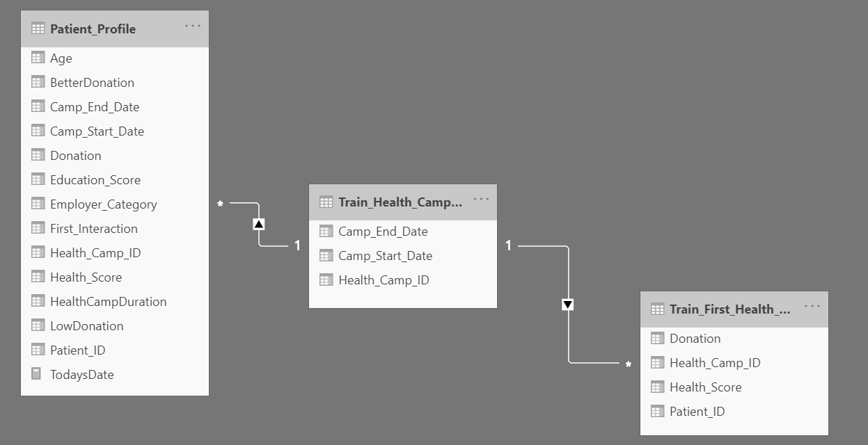

**Data:**

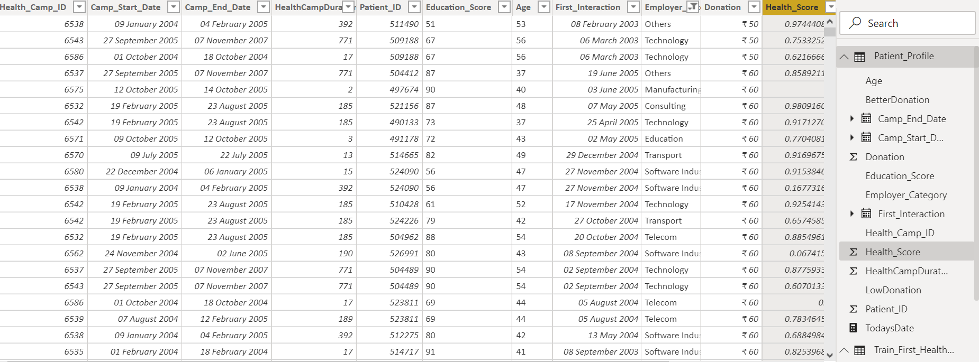

**Dashboards:**

